AWS QuickSight Sales Data Visualization

Objective: Utilize AWS QuickSight to perform detailed visualizations on sales data to gain insights into sales performance across different industries and regions.

# Outcome:

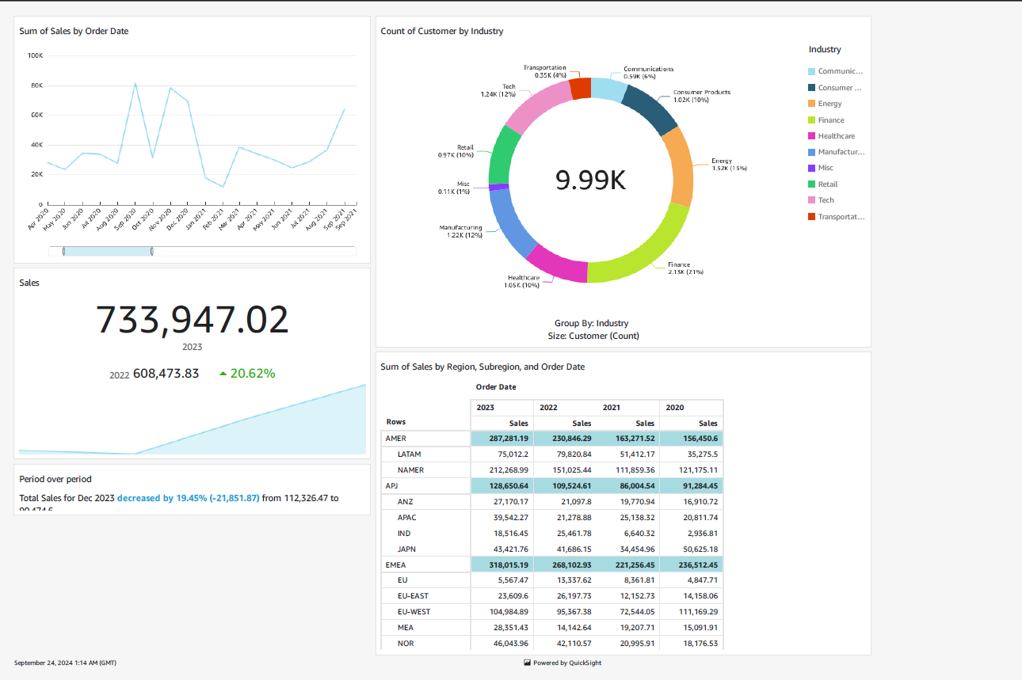

# Project Steps:

**Prepare the Data:**

* Gather sales data from various sources and consolidate it into a CSV file.
* Ensure the data is clean and formatted correctly for visualization.

**Upload Data to AWS S3:**

* Upload the consolidated sales data CSV file to an Amazon S3 bucket for easy access by QuickSight.

**Create a Dataset in AWS QuickSight:**

* Connect AWS QuickSight to the S3 bucket containing the sales data.
* Create a new dataset and configure data ingestion settings.

**Perform Data Analysis and Visualizations:**

* Use AWS QuickSight to create various visualizations and dashboards to analyze sales data.
* Create visualizations such as bar charts, line charts, and pie charts to represent different metrics.

# Visualizations:

**Sum of Sales by Order Date:**

* Analyzed the total sales over time to identify trends and seasonal patterns.

**Count of Customer by Industry:**

* Grouped sales data by industry to understand which industries contribute most to sales.

**Sum of Sales by Region, Subregion, and Order Date:**

* Analyzed sales performance across different regions and subregions.
* Visualized data to identify regional sales trends and compare performance year over year.

# Key Findings:

**Industry Analysis:**

* Industries such as Technology and Retail showed the highest sales, indicating strong performance in these sectors.
* Communication and Energy sectors had lower sales, highlighting potential areas for improvement or further investigation.

**Regional Analysis:**

* Sales were highest in regions like North America (NAMER) and Europe (EU), with significant contributions from LATAM and APAC regions as well.
* Year-over-year comparison showed a 20.62% increase in sales from 2022 to 2023.

**Seasonal Trends:**

* Observed a decrease in total sales for December 2023 by 19.45% compared to December 2022, indicating possible seasonal fluctuations.